Exam Revision

# Criterion A

* 1. explain scientific knowledge
  2. apply scientific knowledge and understanding to solve problems set in familiar and unfamiliar situations
  3. analyse and evaluate information to make scientifically supported judgments.

This is going to examine your knowledge. You should be able to recall definitions of keywords, use key terminology in answering questions and be able to apply your knowledge into abstract situations.

Examples

**State** the name of the organ system that carries blood

**Outline** the process of krebs cycle

**Compare** and **contrast** photosynthesis and respiration

**Explain** how bacteria have become resistant to anti-biotics

**Outline** the flow of blood through the heart

# Criterion B

1. explain a problem or question to be tested by a scientific investigation
2. formulate a testable hypothesis and explain it using scientific reasoning
3. explain how to manipulate the variables, and explain how data will be collected
4. design scientific investigations.

This will be examining your ability to plan an investigation. You should be able to create a research question and hypothesis, identify IV, DV and 3 CVs. Units need to be included and correct measuring equipment.

You need to be able to write a step by step method outline how you would carry out an investigation.

**Long Question**

Example

Design an investigation to study how temperature is related to osmosis in potato cells. In your investigation, you should include:

* an identification of the independent, dependent and control variables
* a hypothesis that your method will test
* how you will manipulate the variables
* a list of equipment you will use
* a description of your method
* how you will ensure your method is safe

**Marking scheme**:

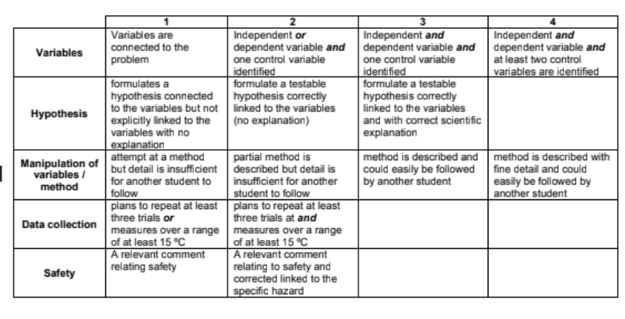

**Short Questions**

Usually you are given a description of an investigation and asked questions about it

Examples

**Outline** the problem (research question) being tested in this investigation

**Suggest** a suitable hypothesis for this investigation

**State** the independent variable

**Identify** the dependent variable

**State** two things which need to be controlled in the investigation

**Explain** how the student kept the investigation fair

# Criterion C

1. present collected and transformed data
2. interpret data and explain results using scientific reasoning
3. evaluate the validity of a hypothesis based on the outcome of the scientific investigation
4. evaluate the validity of the method
5. explain improvements or extensions to the method.

This will be examining your ability to process and evaluate data. There are 3 types of questions you could get.

* 1. **Questions involving graphs/calculations/tables linked with data.**

Example

**Calculate** the mean average of the data.

|  |  |  |  |  |  |  |
| --- | --- | --- | --- | --- | --- | --- |
| **Distance from light/cm** | **Bubbles of gas/min** | | | | | |
| **Trial number** | | | | | |
| **1** | **2** | **3** | **4** | **5** | **Average** |
| 10 | 118 | 89 | 106 | 114 | 101 |  |
| 20 | 109 | 99 | 102 | 95 | 112 |  |
| 30 | 59 | 60 | 65 | 54 | 61 |  |
| 40 | 19 | 22 | 29 | 31 | 25 |  |
| 50 | 8 | 15 | 11 | 4 | 6 |  |

**Present** the transformed data in a graph. (Transformed data is the average you calculated)

**Calculate average:**

T1+T2+T3+T4+T5

5

**Drawing graph:**

Make sure you include:

Correct scale of axis, correct choice of line/scatter/curve/bar, labelled axis, correct plotted points, units, title.

* 1. **Drawing conclusions from data**

Examples

**State** a trend in the data

**Explain** a scientific reason for the difference in final and initial biomass

**Comment** on the validity of the hypothesis based on the data

* 1. **Evaluating a method**

Examples

Based on the method presented, **describe** one strength and one weakness related to the method’s design.

**Outline** two improvements to the investigation. **Justify** your answer.

**State** an extension to this method that would benefit the investigation.

# Criterion D

1. explain the ways in which science is applied and used to address a specific problem or issue
2. discuss and evaluate the various implications of using science and its application to solve a specific problem or issue
3. apply scientific language effectively
4. document the work of others and sources of information used.

This will be examining your ability to apply your scientific knowledge into real life situations. You will usually get a long answer essay style question and some short answer questions.

Examples

**Long Question**

Consider the factors that affect the rate of photosynthesis. Discuss and evaluate the impact of farmers manipulating the rate photosynthesis in order to increase crop growth and production. In this extended piece of writing you should support your answer with scientific explanations considering:

* What are the factors that affect photosynthesis?
* How could these factors be manipulated?
* The impact of this on the environment and/or the economy.

**Marking scheme:**

|  |  |  |  |  |
| --- | --- | --- | --- | --- |
|  | 1 | 2 | 3 | 4 |
| Evaluation | A statement relating to the topic identified in the question | A statement relating to the topic identified in the question | More than one statement relating to the topic identified in the question including a positive and negative impact | More than one statement relating to the topic identified in the question including a positive and negative impact and a possible alternative where suitable |
| Factor 1 | A statement of factor impact | More than one statement of factor impact | Positive and negative statements of factor impacts |  |
| Factor 2 | A statement of factor impact | A statement of factor impact with a linked consequence | Positive and negative statements of factor impacts with a linked consequence. |  |
| Conclusion | Appraisal given | Appraisal linked to previous impacts giving writers opinion |  |  |

**Short Questions**

**Justify** using scientific reasoning why 2 organisms in an ecosystem are equally important to protect.

**Explain**, using scientific language, why the loss of one species in an ecosystem might affect another species.

**Outline** how one specific human action can reduce biodiversity.